**CPSC449 W23 - Assignment 2**

**Questions in this assignment are about recursive functions, tuples, and lists. The first two questions are from the textbook (**Haskell-The Craft of Functional Programming_3rd **) and the last three are from Robin’s exercises.**

**instructions:**

1. Students are just allowed to use Prelude (no other libraries)
2. They should provide enough comments to explain their solutions

**Q1** From textbook (P91)

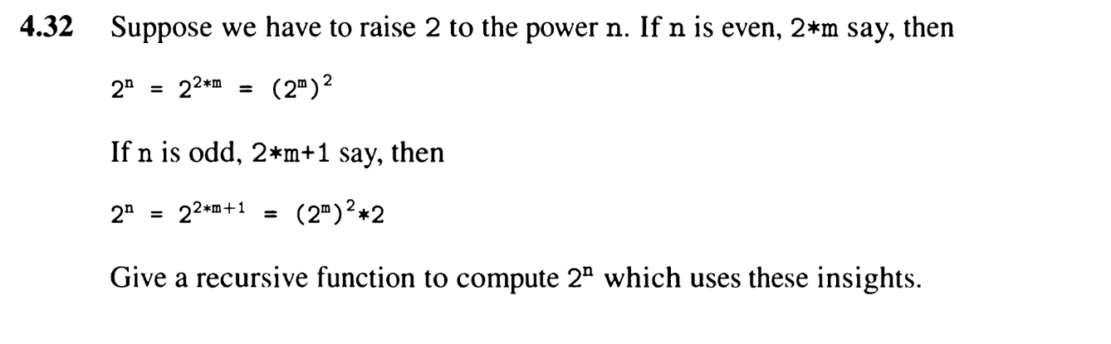

**Q2** From textbook (P115)

Hint: you can use list comprehension

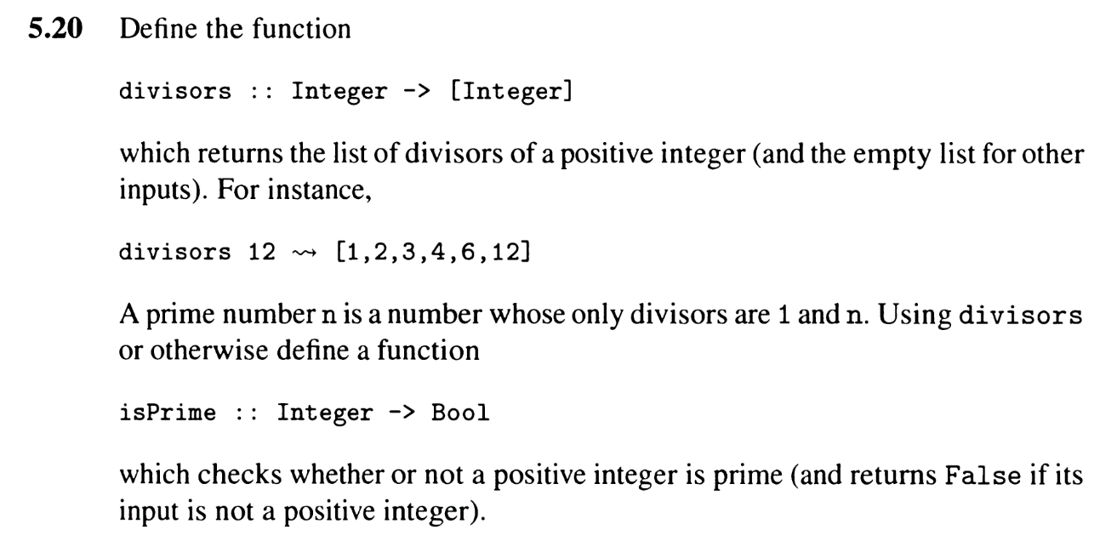

**Q3** (From Robin’s Exercises (exercise 1, question 7)

**3.**Write a function:

instrictorder:: [Int]-> Bool

which tests whether the list of integers is strictly decreasing

**Q4** (From Robin’s Exercises (exercise 1, question 5)

**4.** The binomial coefficient n k is defined as follows for integers n ≥ 1 and 0 ≤ k ≤ n:

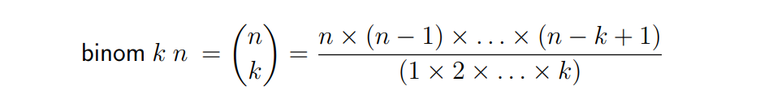

Write a function:  
binom :: Integer -> Integer -> Integer

to calculate the binomial coefficients.

**Q5.** From textbook (P115)

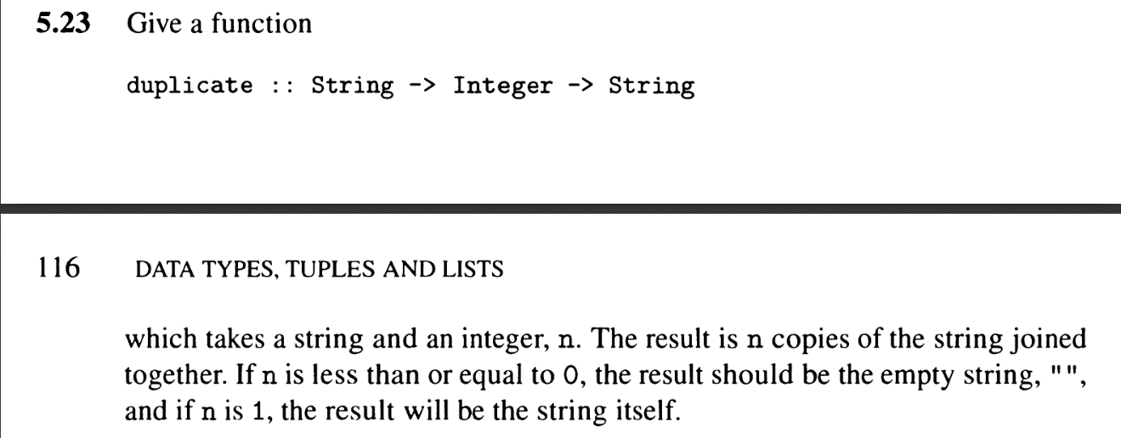

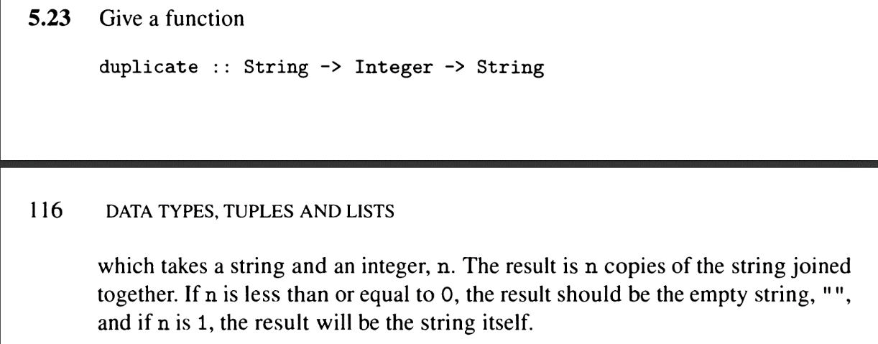

**Marking criteria (1 mark for each question)**

* Correct Implementation - 0.7
* Comments - 0.3